

STEM Drive Ltd
Solway Works, Eastriggs,
Annan, Dumfriesshire
UK DG12 6NU
T 01461 40904
E-mail: info@Stemdrive.com

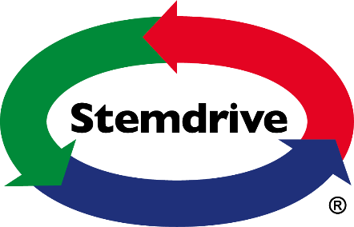

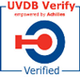


COMPANY ENVIRONMENTAL POLICY

Objective:
“Environmentally safe operation of all activities with no damage to, property and the environment”.

Policy Statement

STEM Drive Ltd recognises that its day to day operations impact on the environment in a number of ways. The Company wishes to minimise the potential harmful effects of such actions wherever and whenever this is reasonably practicable. Through managing its own performance, STEM Drive Ltd can affect its own impact on the local environment and identify improved performance and good practice. The Company also seeks to change attitudes and encourage others to contribute to more effective environmental management. ‘This policy, therefore, is to enable STEM Drive Ltd to take effective control of its own business impact on the environment’.

STEM Drive Ltd will manage all activities to minimise wherever reasonably practicable their effect on the environment. In this, the Company is committed within all levels within all functions of the organisation to continual improvement. The Company recognise that this will only be achieved through regular monitoring of environmental performance. With this in mind, environmental objectives and targets will be set which will be regularly reviewed to ensure continual improvement.

The Environmental Policy of STEM Drive Ltd commits the organisation at all levels to ensure that it:-

- Identifies any risk of pollution arising from any of the Companies activities,
Products and/or services, which shall be either eliminated or effectively
controlled to meet or exceed all regulatory requirements relating to the
environment.

- Reduces to a minimum unnecessary use of materials, resources and energy.

- Reduces waste to the lowest reasonable practicable level ensuring
responsible disposal of waste created and received, undertaking
environmental audits and measuring the results against established targets.

- Advocates employee involvement in all environmental matters and provides
Suitable training and support to all employees with regard to this environmental policy.

- Minimises’ any environmental effects caused as a result of the Companies
Activities, products and/or services adopting the technique of BAT (NEEC) (Best Available Techniques (Not Entailing Excessive Costs)).

- Ensures that any persons working on the Companies behalf are made aware of and
agree to comply with this policy.

- Seeks to ensure that products and/or services supplied or provided by third parties
can be used, handled, stored and disposed of in a manner which safeguards the environment and the health and safety of all involved.

- Undertakes a review of this policy in the light of any new knowledge, changing
legislation or public concerns.

STEM Drive Ltd recognises that environmental issues are of fundamental importance to a successful and responsible business strategy. Therefore, the Company is committed, through a process of continual improvement, to minimising the environmental impact of its operations. In line with this commitment STEM Drive Ltd will:-

- Ensure that its operations comply with all relevant legislation, including the Environmental Protection Act 1990, the Environmental act 1995, the Control of Pollution Act 1975 and the Pollution Prevention and Control (Scotland) Regulations 2000.
- Manage all environmental issues either at, or as close to, their source as reasonably practicable.
- Minimise energy usage and waste wherever reasonably practicable, e.g. use ‘skype’ or teleconference instead of travelling to site or client’s office.
- Reuse or recycle materials wherever reasonably practicable.
- Set environmental targets which it will strive to achieve.
- Seek to purchase goods and services from environmentally responsible companies.
- Communicate its environmental policy and practices at all levels and at all sites of the organisation.
- Monitor progress using internal and external auditing and regularly report on its environmental management performance.
- Review its environmental policy on a regular basis.

Organisation

Mr. Graham Hind is responsible for establishing policy matters relating to environmental issues. He has ultimate responsibility for ensuring that policies are implemented throughout the Company, and ensuring that environmental performance is monitored.

In addition, all employees have responsibilities towards working in a way that does not adversely affect the environment. All employees are expected to co-operate with STEM Drive Ltd in carrying out this policy and must ensure that the way in which they carry out their work activities conform to the general, and where appropriate more specific instructions contained within this Policy Statement.

A copy of this Environmental Policy Statement will be available for inspection at STEM Drive Ltd, at the above address.

This Environmental Policy Statement will be reviewed and revised on an annual basis.

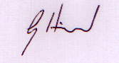

G. Hind
Managing Director
Reviewed 30th January 2025

